**Name: Debolina Hait**

**Department: MCA**

**Semester : 3rd Semester**

**Year: 2nd Year**

**Batch: 2020-2022**

**Roll Number: 14271020002**

**Project: Minor Project**

Minor Project Name: A Realm of Books

* **Home Page:**



This page contains the genre of books the viewer wants to read.

User has the option to navigate to Home page, Login page & Contact Us page at any time.

Each genre is clickable and on clicking the respective genre, it redirects to a page where all the books related to that genre is listed.

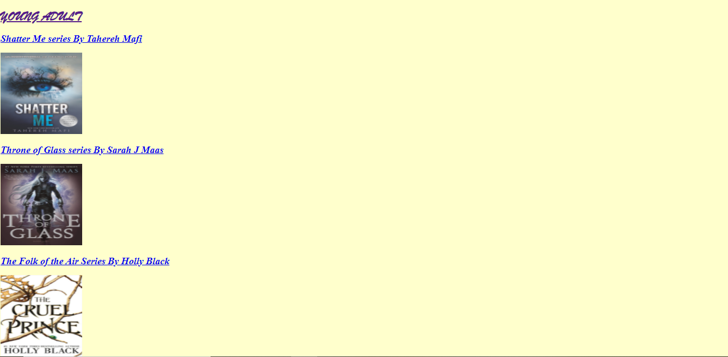

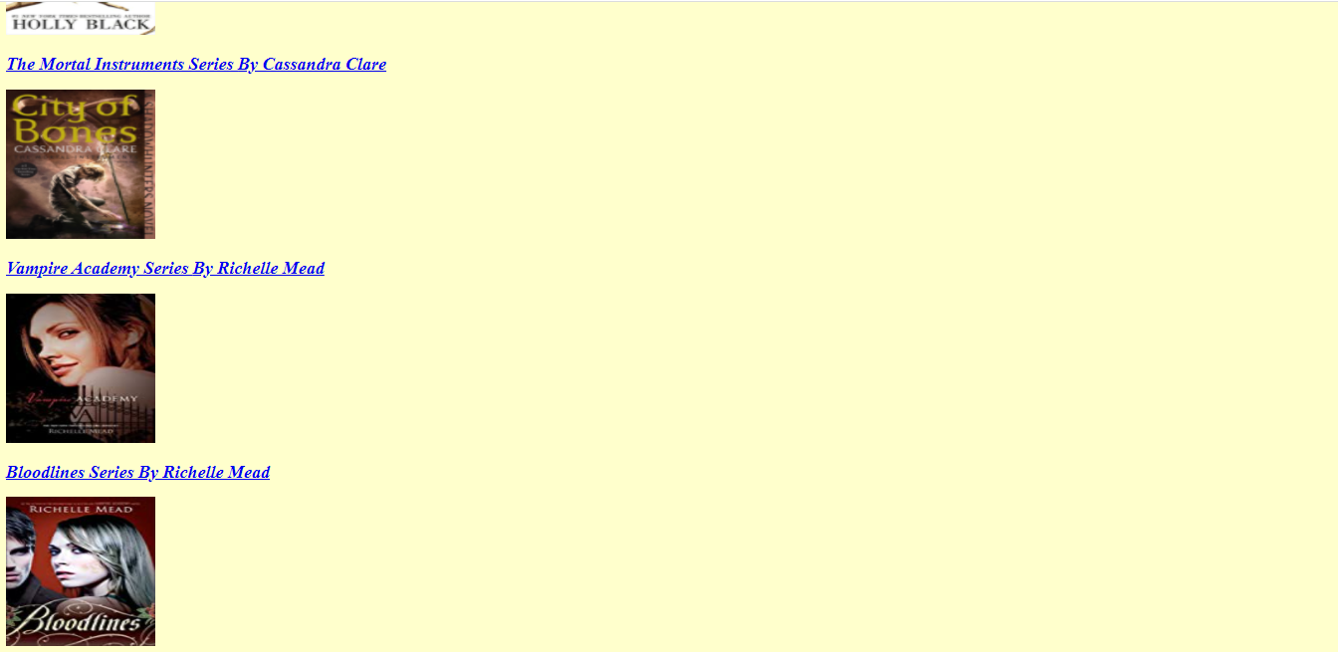

Clicking on each book’s series name redirects to an external site which details about the book series. For instance:

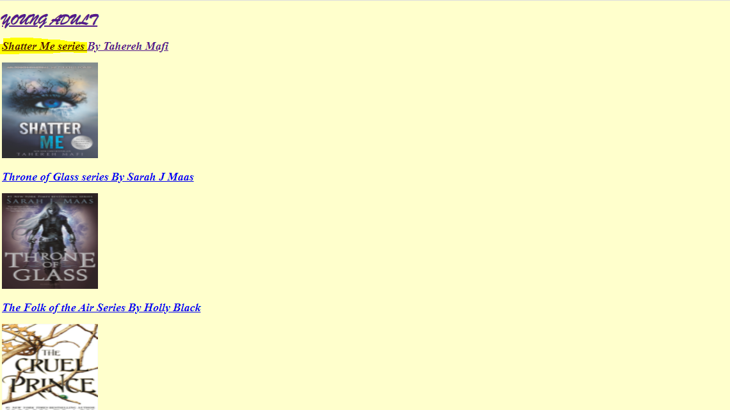

Clicking on the highlighted portion, user gets redirected to:

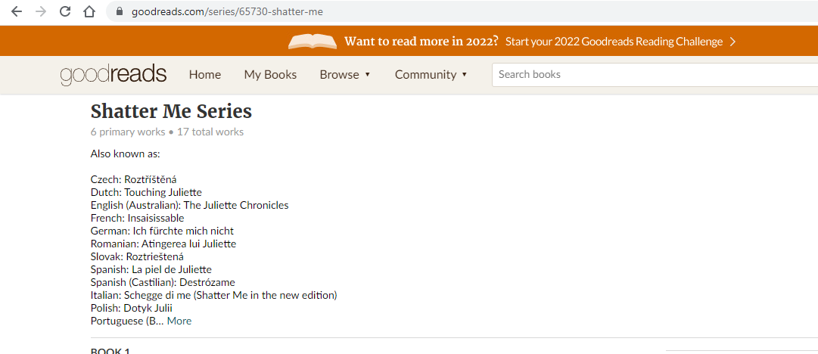

On clicking the author’s name, it redirects to an external site(Wikipedia page of the author). Same redirection happens if the end user clicks on the book image. For instance:

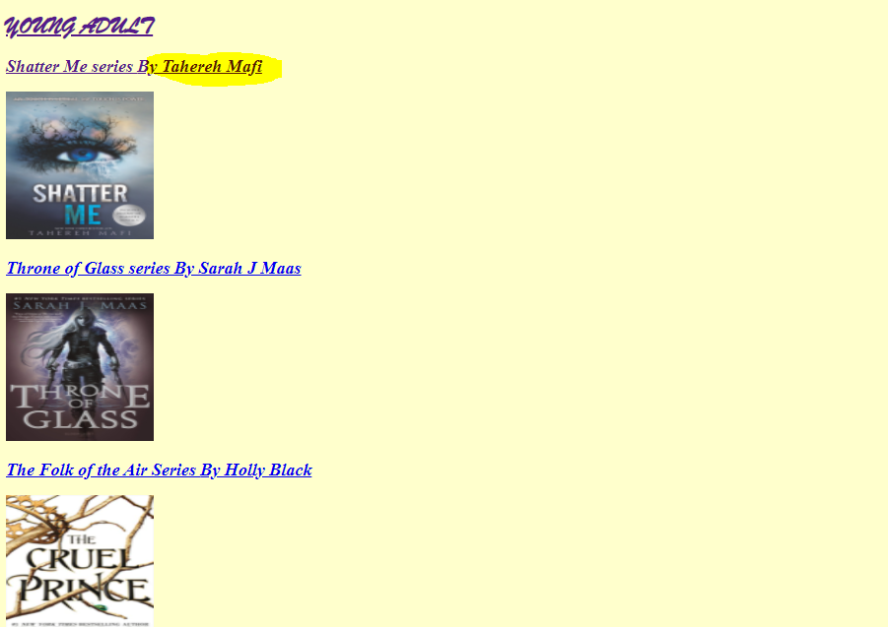

Clicking on the highlighted portion, user gets redirected to:

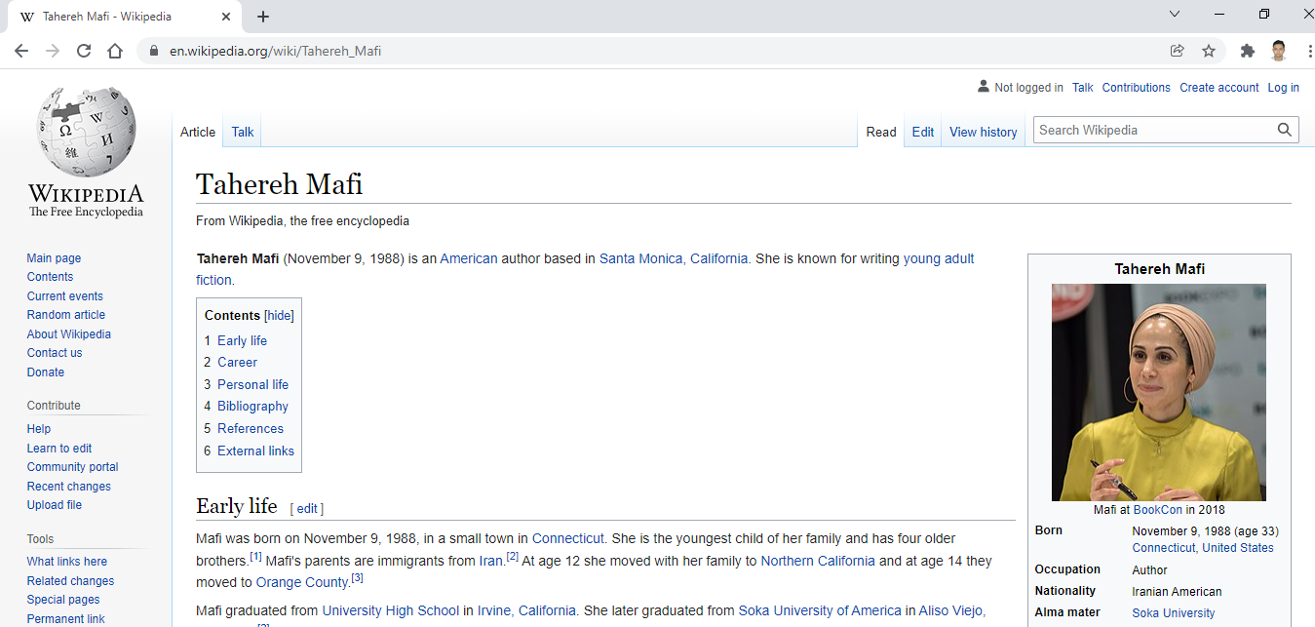

* **Login Page:**

Login Page, if the user is an existing user:

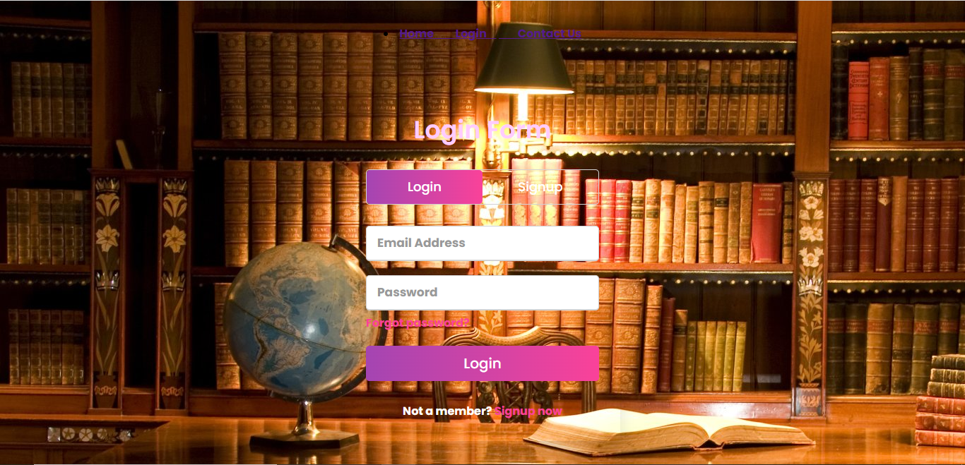

Registration page, if the user is a new user and needs to click on Signup tab

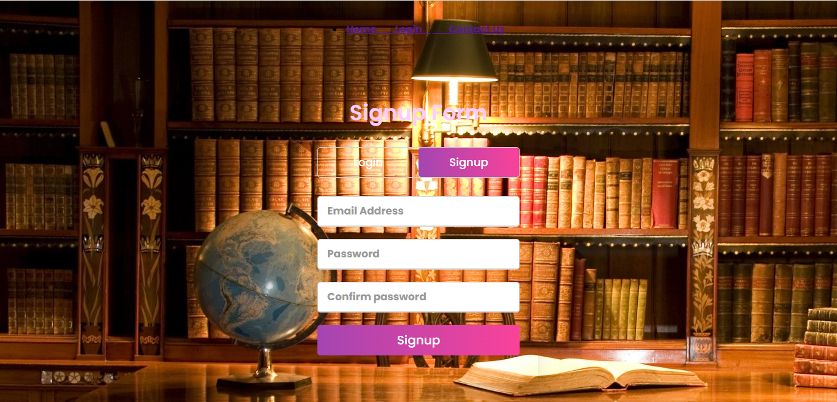

User has the option to navigate to Home page, Login page & Contact Us page at any time.

* **Contact Us Page:**

This page contains the conact details and also offers the end user to contact the team.

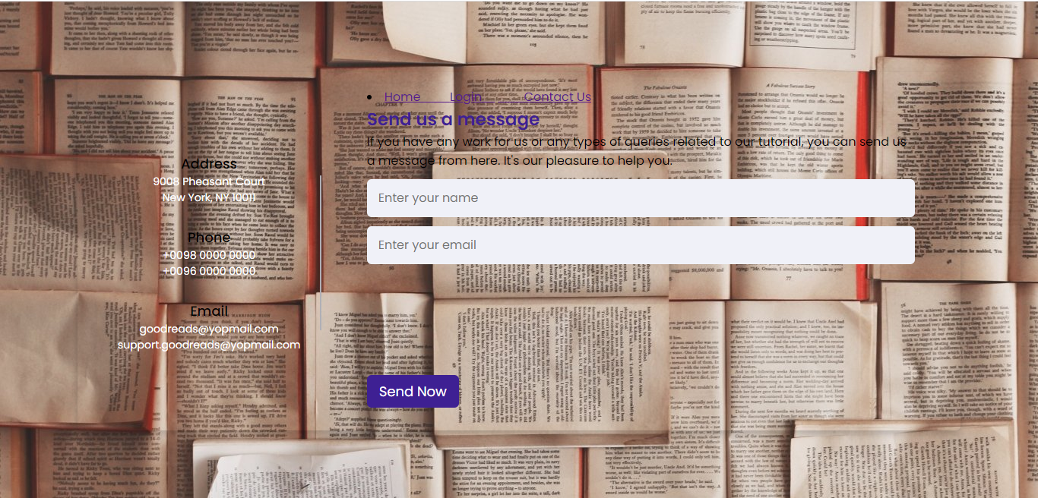

User has the option to navigate to Home page, Login page & Contact Us page at any time.

**\*\*\*\*\*\*\*\*\*\*\*\*\*\*\*\*\*\*\*\*\*\*\*END\*\*\*\*\*\*\*\*\*\*\*\*\*\*\*\*\*\*\*\*\*\*\***